Aim: - Blinking LEDs in different pattern of mbed NUCLEO-L152RE using mbed software.

Software Used: -

Cloud Keil Studio IDE

Theory: -

The mbed NXP LPC11U24 Microcontroller in particular is designed for prototyping low-cost USB devices, battery powered applications and 32-bit ARM® Cortex™-M0 based designs. It is packaged as a small DIP form-factor for prototyping with through-hole PCBs, stripboard and breadboard, and includes a built-in USB FLASH programmer.

Specifications of LPC11U24:

* NXP LPC11U24 MCU
* Low power ARM® Cortex™-M0 Core
* 48MHz, 8KB RAM, 32KB FLASH
* USB Device, 2xSPI, I2C, UART, 6xADC, GPIO
* Prototyping form-factor
* 40-pin 0.1" pitch DIP package, 54x26mm
* 5V USB, 4.5-9V supply or 2.4-3.3V battery
* Built-in USB drag 'n' drop FLASH programmer
* mbed.org Developer Website
* Lightweight Online Compiler
* High level C/C++ SDK
* Cookbook of published libraries and projects

API Used:

* Syntax used for digital output:
* DigitalOut (Pin Name pin)
* For LED blinking we’ve used:
* DigitalOut variable (LEDn); where n= 1,2,3,4
* For delay:
* wait(t); where ‘t’ is in seconds

Task 1: - Write a program to blink the On-board LED with 500ms delay. Simulate and verify this logic on Nucleo-STM32l152 using Keil Studio IDE.

Code: -

#include "mbed.h"

DigitalOut leds(LED1);

int main() {

  while(1) {

    leds = 1;

    wait(0.2);

    leds = 0;

    wait(0.2);

  }

}

Output: -

LED OFF: -

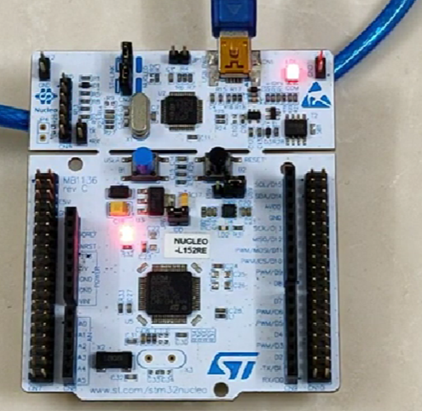

LED ON: -

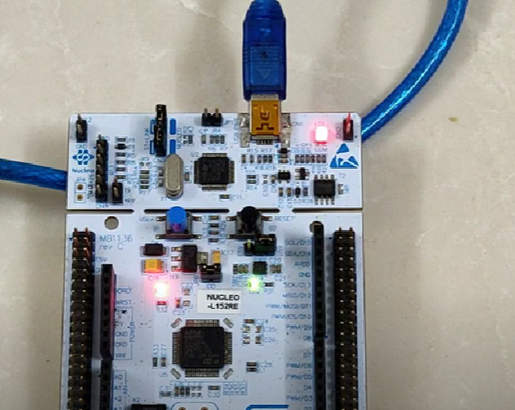

Task 2: - Write a program to interface an external LED to pinPA_5 and blink with 0.5 Sec delay. Between each. Simulate and verify his logic on using Nucleo-STM32l152 Keil IDE.

Code: -

#include "mbed.h"

DigitalOut leds(LED1);

int main() {

  while(1) {

    leds = 1;

    wait(0.2);

    leds = 0;

    wait(0.2);

  }

}

Output: -

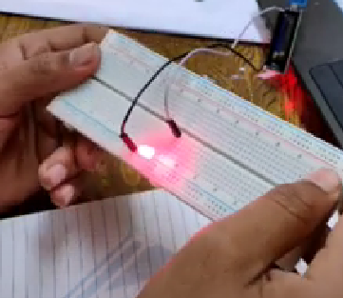

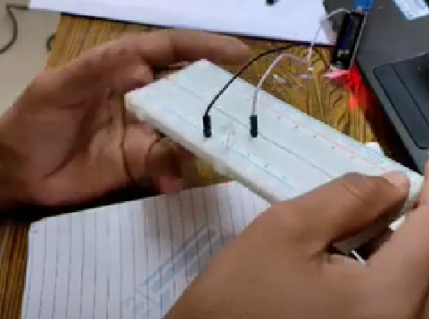

Challenging Task: -

Write a program to interface four external LEDstopinPC_4 and blink alternate LED to generate 1010 and 0101 with 0.5 Sec delay between each pattern. Simulate and verify his logic on Nucleo-STM32l152 using Keil IDE.

Code: -

#include "mbed.h"

DigitalOut led(PA_5);

DigitalOut led1(PA_6);

DigitalOut led2(PA_7);

DigitalOut led3(PB_6);

int main()

{

  while(1)

  {

    led = 1;

    led1 = 0;

    led2 = 1;

    led3 = 0;

    wait(0.5);

    led = 0;

    led1 = 1;

    led2 = 0;

    led3 = 1;

    wait(0.5);

  }

}

Output: -

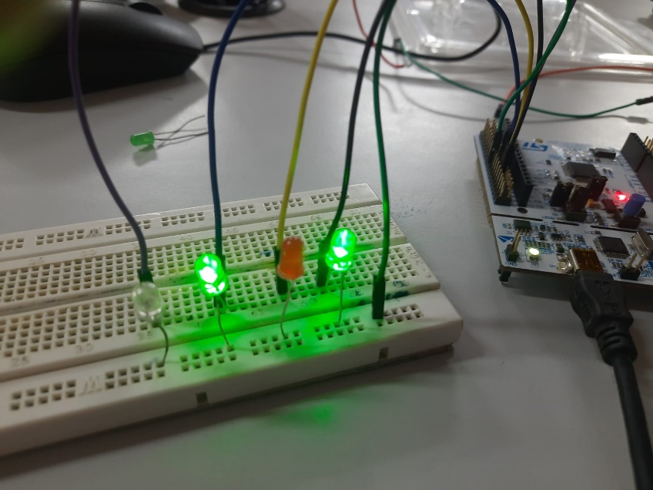

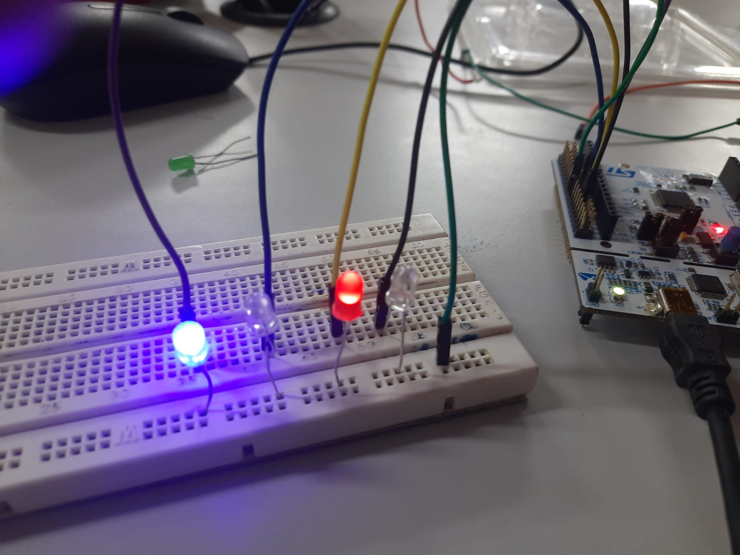

Result: - All the tasks are completed and verified in lab